Analysis Customer Segmentation using K-Means

Nguyen D.D, Nune, Lia
Information System Institute
The State University of Management
Ryazanskiy Prospekt, 99, Moscow, 109542
Email: Dungduongthanhson@gmail.com
s122926@guu.ru

Abstract— Customer segmentation is the practice of dividing a company’s customers into groups that reflect similarity among customers in each group. The goal of segmenting customers is to decide how to relate to customers in each segment in order to maximize the value of each customer to the business.

Introduction
At its most basic, customer segmentation (also known as market segmentation) is the division of potential customers in a given market into discrete groups.
There are three main approaches to market segmentation:
1/ A priori segmentation, the simplest approach, uses a classification scheme based on publicly available characteristics — such as industry and company size — to create distinct groups of customers within a market. However, a priori market segmentation may not always be valid, since companies in the same industry and of the same size may have very different needs.
2/ Needs-based segmentation is based on differentiated, validated drivers (needs) that customers express for a specific product or service being offered. The needs are discovered and verified through primary market research, and segments are demarcated based on those different needs rather than characteristics such as industry or company size.
3/ Value-based segmentation differentiates customers by their economic value, grouping customers with the same value level into individual segments that can be distinctly targeted.

Benefits of Customer Segmentation
At the expansion stage, executing a marketing strategy without any knowledge of how your target market is segmented is akin to firing shots at a target 100 feet away — while blindfolded. The likelihood of hitting the target is a matter of luck more than anything else.
Without a deep understanding of how a company’s best current customers are segmented, a business often lacks the market focus needed to allocate and spend its precious human and capital resources efficiently. Furthermore, a lack of best current customer segment focus can cause diffused go-tomarket and product development strategies that hamper a company’s ability to fully engage with its target segments. Together, all of those factors can ultimately impede a company’s growth.
If best current customer segmentation is done right, however, the business benefits are numerous. For example:
- Improving your whole product
- Focusing your marketing message
- Allowing your sales organization to pursue higher percentage opportunities
- Getting higher quality revenues
- Etc.,

Customer Segmentation Using Cluster Analysis
In brief, cluster analysis uses a mathematical model to discover groups of similar customers based on finding the smallest variations among customers within each group. The process is not based on any predetermined thresholds or rules (as are most simple segmentation methods), but rather the data itself generates the customer prototypes that inherently exist within the population of customers.
The two main advantages of cluster analysis over simple threshold/rule-based segmentation:
1/ Practicality – it would be practically impossible to use predetermined rules to segment customers over many dimensions.
2/ Homogeneity – variances within each resulting group are very small in cluster analysis, whereas rule-based segmentation typically groups customers who are actually very different from one another.
The customer segmentation process can be performed with various clustering algorithms. We focused on K-Means clustering in Python. While the algorithm is quite simple to implement, half the battle is getting the data into the correct format and interpreting the results.

How K-Means Algorithm Works
The k-means clustering algorithm works by finding like groups based on Euclidean distance, a measure of distance or similarity.
Algorithm:
1/ Clusters the data into k groups where k is predefined
2/ Select k points at random as cluster centres.
3/ Assign objects to their closest cluster centre according to the Euclidean distance function.
4/ Calculate the centroid or mean of all objects in each cluster.
5/ Repeat steps 2, 3 and 4 until the same points are assigned to each cluster in consecutive rounds.
K-Means is relatively an efficient method. However, we need to specify the number of clusters, in advance and the final results are sensitive to initialization and often terminates at a local optimum. Unfortunately, there is no global theoretical method to find the optimal number of clusters. A practical approach is to compare the outcomes of multiple runs with different k and choose the best one based on a predefined criterion. In general, a large k probably decreases the error but increases the risk of over fitting.

Analysis customer segmentation data
We are required to segment potential customers at a new shopping mall from existing customer dataset. From there, a marketing campaign can be launched, maximizing the value (revenue and/or profit) from each customer.
Now we are being hired a new mall and through membership cards, we have some basic data about our customers like customer ID, age, gender, annual income and spending score. Spending Score is something we assign to the customer based on your defined parameters like customer behavior and purchasing data. They all are saved in .csv format.

Data exploration
- Overview customer data.
- First 5 rows in data table
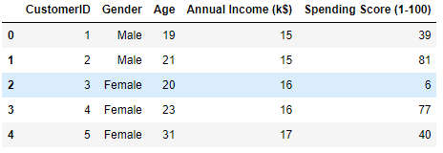
- Descriptive statistics that summarize the central tendency
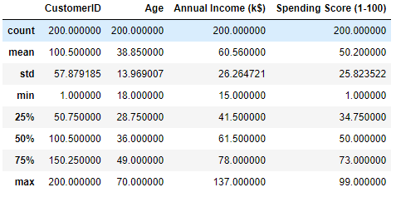
- Data visualization
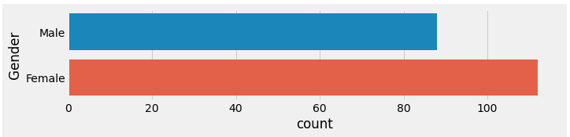
1/ Bar chart of gender

Fig. 1: Count by gender
- The number of female customers is about 10% more than male customers.
2/ Histograms
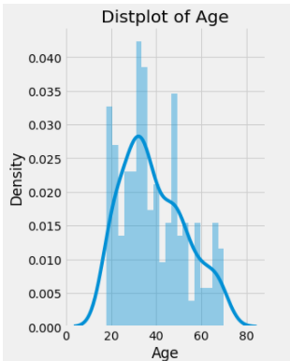
(a) (b)
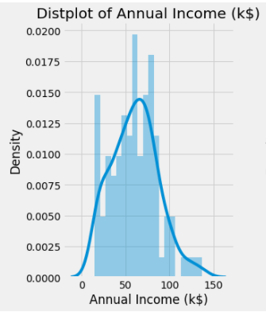
(c)
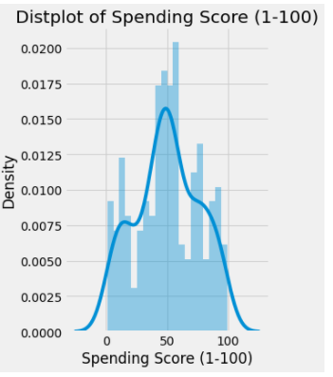

Fig. 2a: Histogram of Age

Fig. 2b: Histogram of Annual income

Fig. 2c: Histogram of Spending Score

- The number of customers coming to the small is mainly young people and is concentrated at around 38 years old
- The number of customers with an income of about 50-83k$ more often visit the store than others
- 50% of customers shop at a average level, the rest is divided equally between high and low levels
3/ The relation between Age, Annual Income and Spending Score.
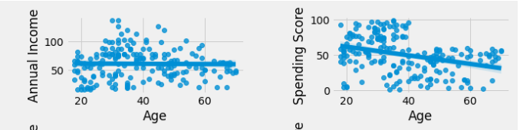
- Spending levels decrease with age.
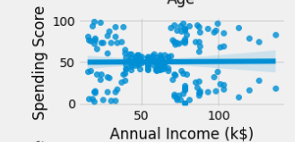
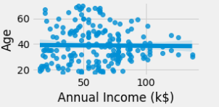
- All customers with an income of 40-60k$ have an average spending level, in addition, it is evenly distributed
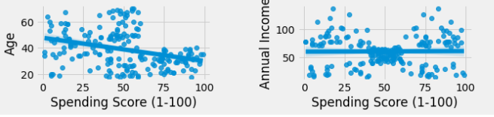
- All customers having 60-100 spending score are under 40 years old
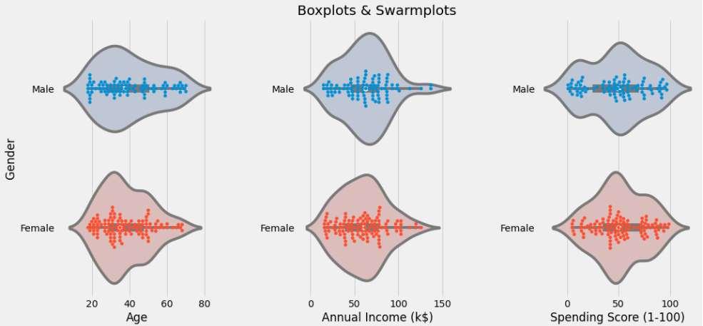
4/ Swarmplot distribution of values according to Gender
- The majority of shoppers are around the age of 35, especially women
- Male customers with annual income greater than 100 do not usually buy good.

K-Means algorithm
- Segmentation using Age and Spending Score
- Selecting N Cluster by using Elbow method
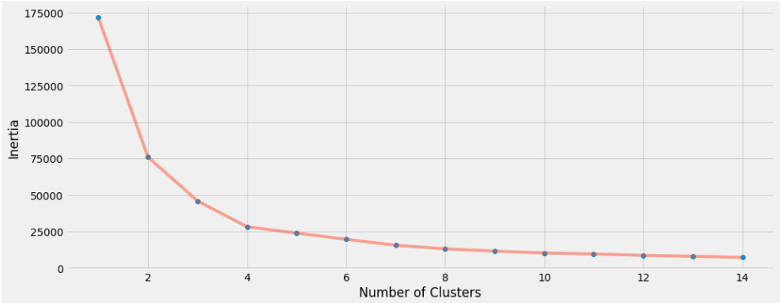
- We should choose N = 4 because the slope drops sharply there.
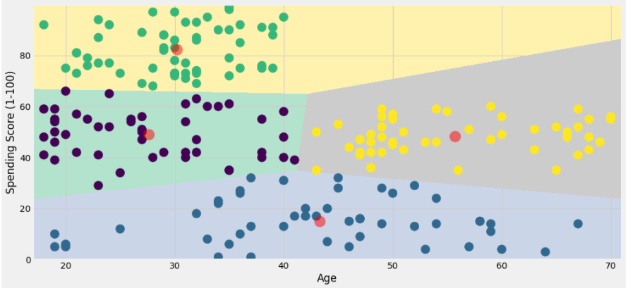
- Predict segmentation
- We can highly focus our resources on the high-spending youth segment
- Segmentation using Annual Income and Spending Score
- Selecting N Cluster by using Elbow method
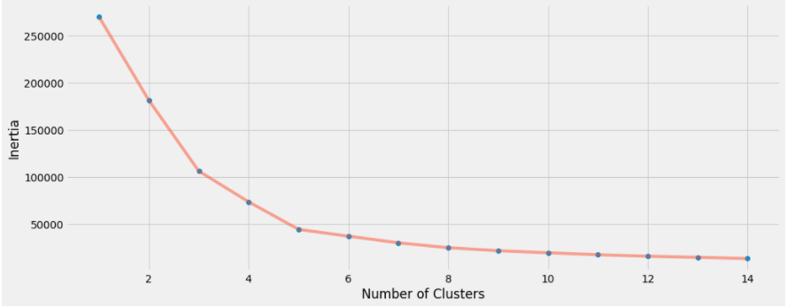
- We should choose N = 5.
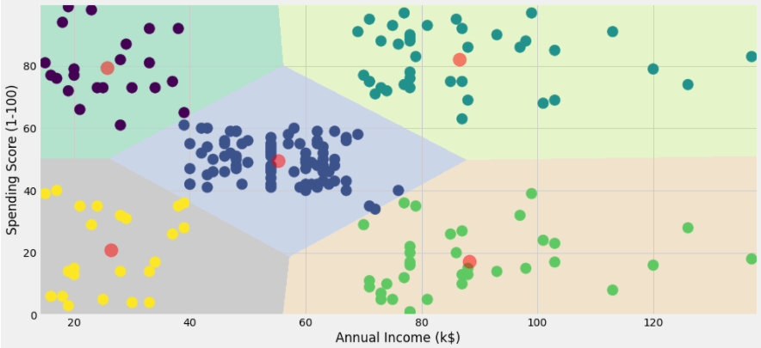
- Predict segmentation
- We can highly focus our resources on the customers having 13-40 and 70-100 annual income.
- Segmentation using Age, Annual Income and Spending Score
- Selecting N cluster by using Elbow method
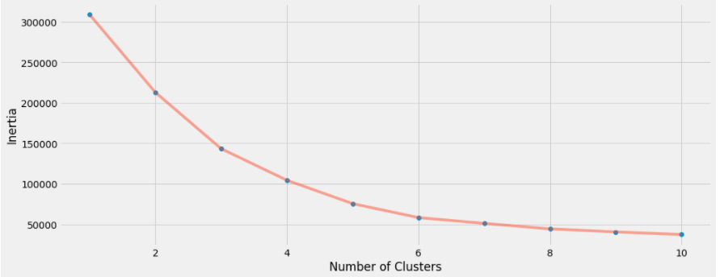
- We should choose N = 6
- Predict segmentation
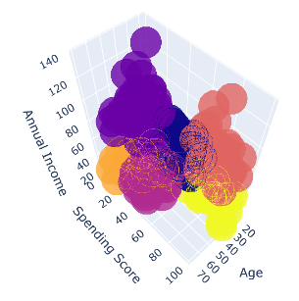
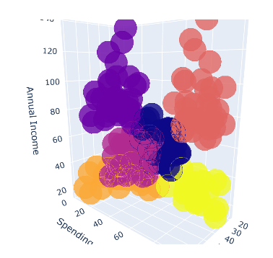

References
Data set is taken from kaggle: https://www.kaggle.com/
Code í run in IDE Jupyter notebook

